IFT 166 Introduction to Internet Networking
Lab 2
Connecting at OSI Layers 2, and 3 & Network Configuration

Note: If possible, try to complete this lab where you have multiple computers on the same network

Connecting at OSI Layers 2, and 3

Objectives
- To investigate network connections at OSI Layers 2 and 3
- To determine network addressing information on a Windows 8 PC

Boot into Windows operating on a computer (couldn’t care which one).
You can also attempt this lab on a MAC (might be a little trickier).

-
Network TCP/IP Configuration
1
- Gather basic TCP/IP configuration information
- Open up the command prompt in Windows
- Type ipconfig & press enter (not case sensitive)

Record the following TCP/IP information for your computer

IP Address | 192.168.1.141
Subnet Mask | 255.255.255.0
Default Gateway | 192.168.1.1

- Compare your computer’s TCP/IP configuration to that of others on the LAN
- Are there any similarities?
Yes/No: Yes
- What is similar about the IP addresses?
The IP address starts similarly (191.168.1.x)
- What is similar about the default gateway?
The Default gateway is identical on two machines on the same LAN

- Check additional TCP/IP configuration information via ipconfig /all
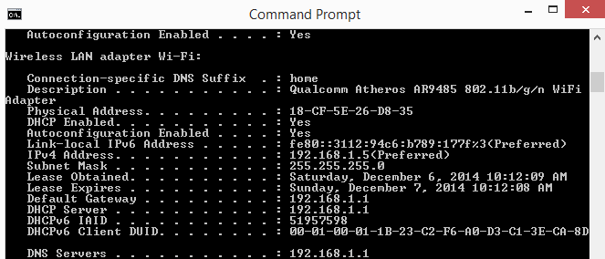

- You should see the following information (computer name, DHCP server’s, if used, and the date the IP lease starts and ends. You might also see entries for DNS servers (used in name resolution)
- You will also see the physical (MAC) address, what is it?

76-82-97-2F-48-89

- Write down the IP addresses of any servers listed?
192.168.1.1
- Write down your computers host name?
DESKTOP-NN132V3
- Write down the host names of couple of other computers on the LAN?
George’s PC, Christine’s Macbook

